October XX, 2024

New Features
Seismic data import has been extended to use the elevation in the file (receiver group elevation field). Tick on the checkbox if you would like to use this feature, and if you have a file with receiver group elevation values.
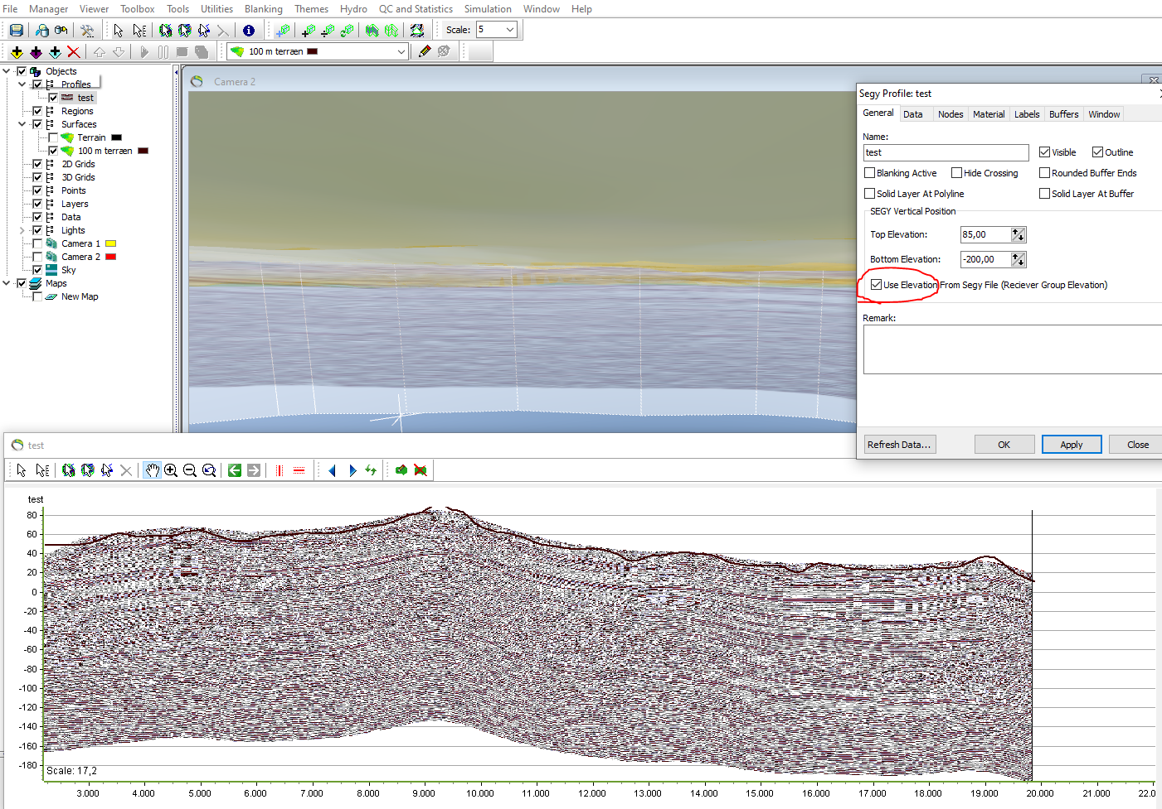

During the import of a csv file, a preview i shown. This helps selecting the delimiters.
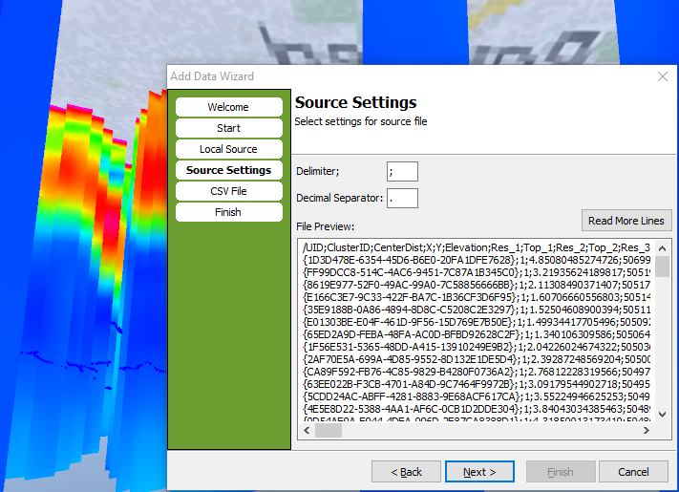

Bug fixes
- Several bugs have been fixed in the importer of ASCII files containing 1D models and DOI. More characters in the header line, e.g. dash (“-“) is accepted. The handling of files with many columns has been improved.
- The import logs button has been restored.
- MPS can now be run successfully when the path contains spaces.

